F-48 -

Functionality
Down Payment is a function that uses Special GL indicators. Special GL Transactions allow the user to post the document to an alternative GL account instead of “normal” vendor’s reconciliation account. They are defined in Customizing for Vendors and Vendors reconciliation accounts.
You can post down payment directly or use Down Payment request as a template.

Scenario
The down payment was sent to the vendor. Now you want to post this down payment.

Requirements
Defined GL indicators, Vendor Master.

Menu Path | Accounting → Financial Accounting → Accounts Payable → Document entry → Down payment → F-48 - Down payment
Transaction Code | F-48

1. Double click on F-48 - Down payment

Post Vendor Down Payment: Header Data

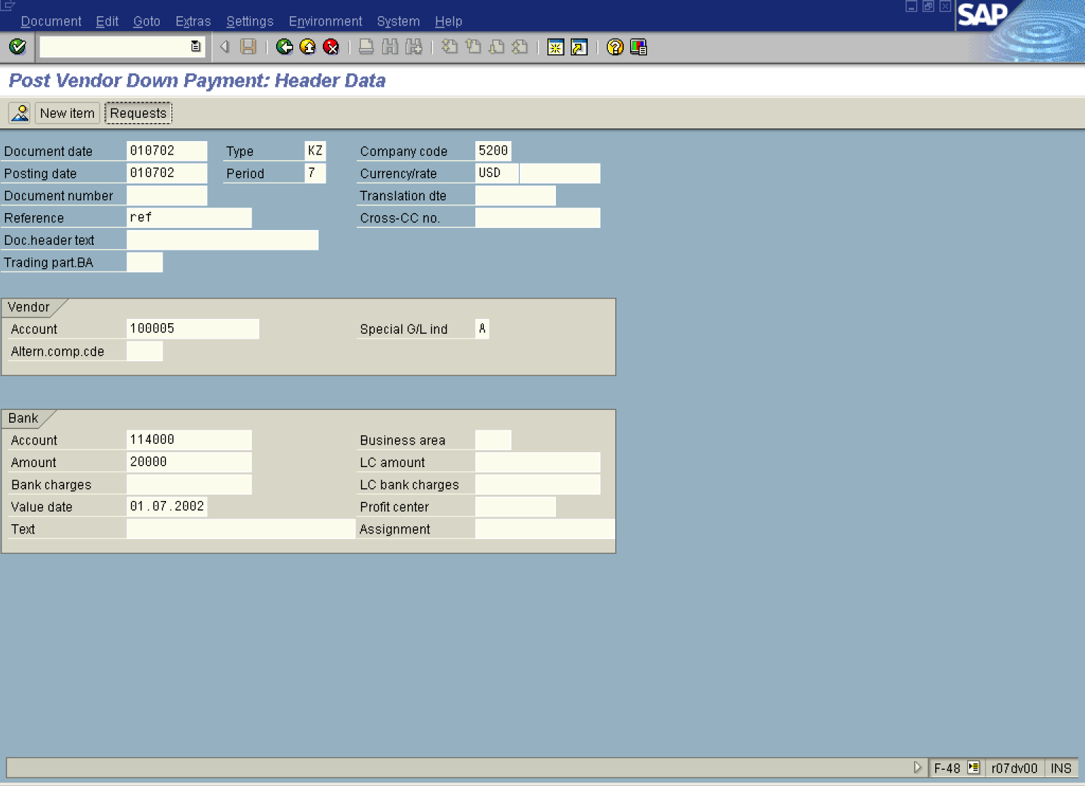

2. Update the following fields:

Field Name | Field Description | Values
Document date | Date the transaction occurred | Example: 010702
Type | Document type | Example: KZ
Company code | Code identifying a separate legal entity for which a separate set of accounts is maintained for external reporting purposes | Example: 5200
Posting date | Date that the business transaction occurred | Example: 010702
Currency/rate | Code identifying the currency used in the transaction | Example: USD
Reference | Description of the Reference. | Example: ref
Account | Vendor account | Example: 100005
Special G/L ind | Enter here required special GL transaction code | Example: A
Account | Bank account number | Example: 114000
Amount | Amount of the line item | Example: 20000

3. You can use an existing down payment request to post the down payment. Click Requests Button .

Post Vendor Down Payment: Choose requests

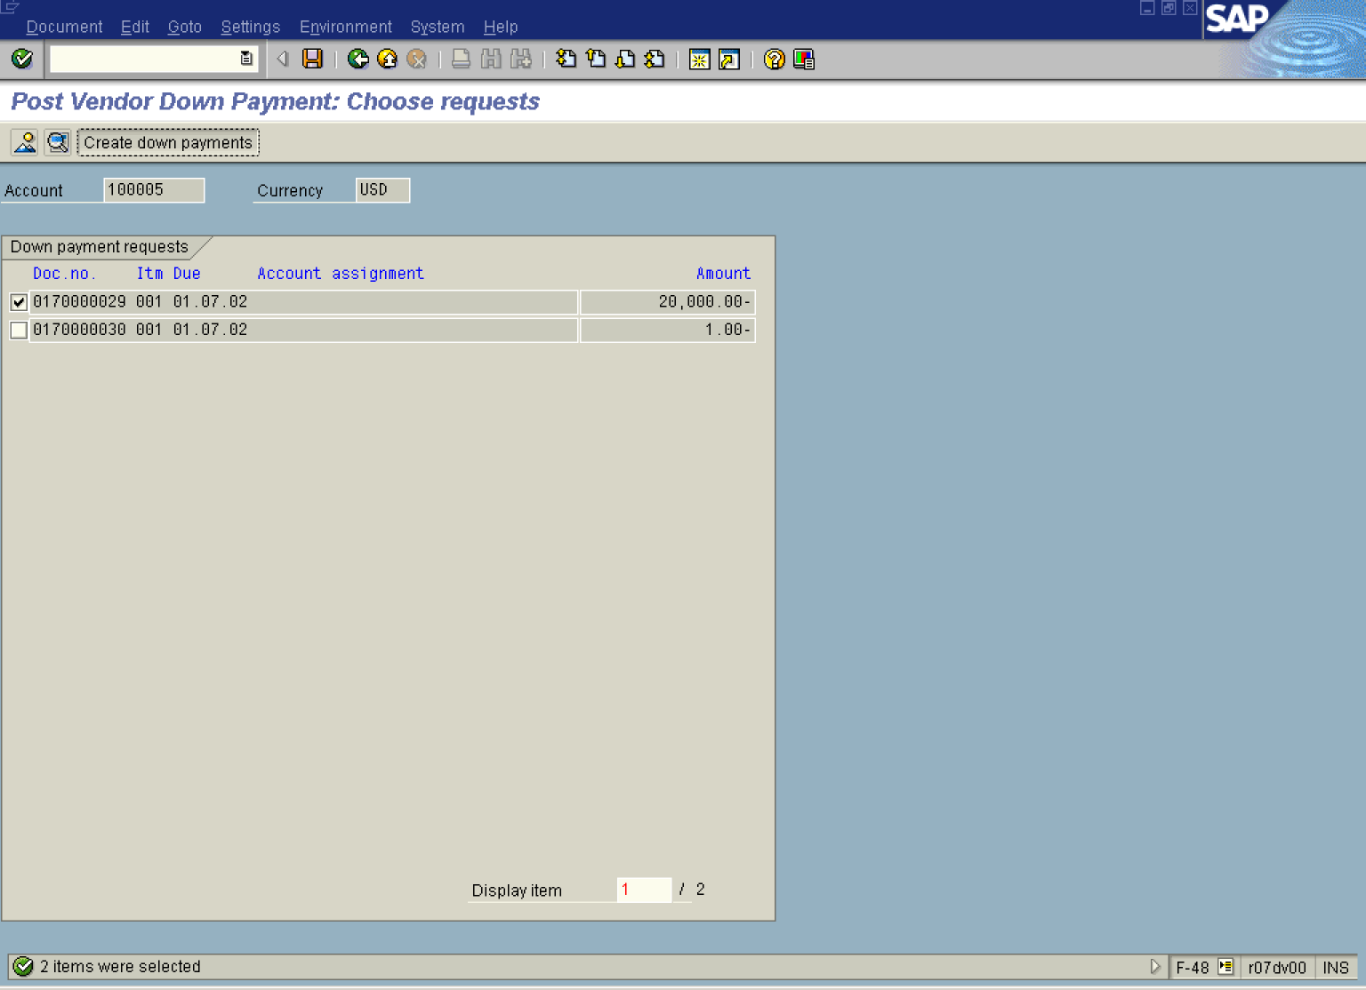

4. Click down payment request radio button .

5. Click Create down payments button . The system will display a document overview:

Post Vendor Down Payment: Display Overview

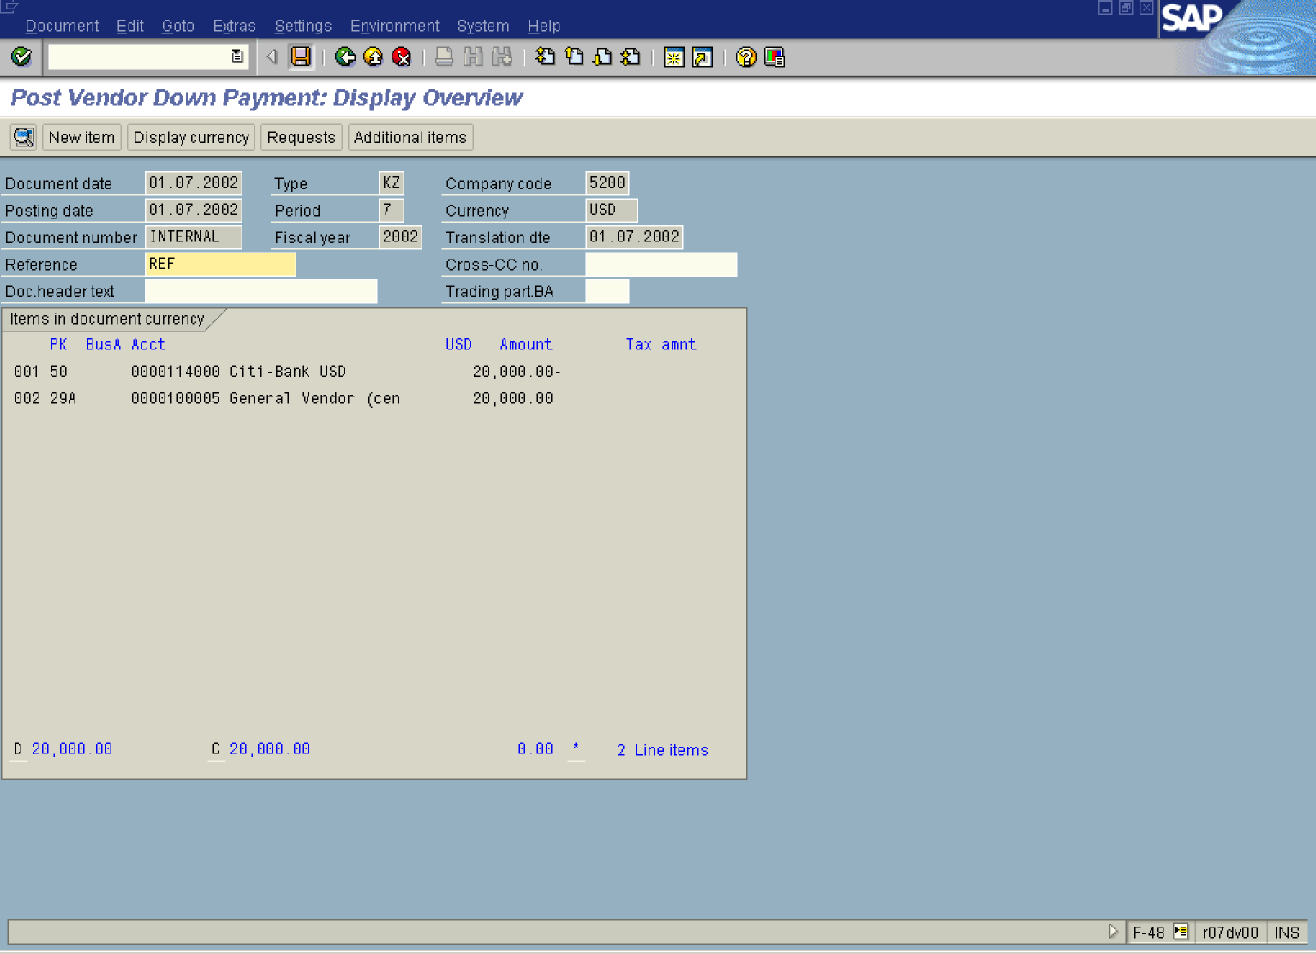

6. Click Save Button. to post the down payment.

7. The message bar displays “Document XXXXXXX was posted in company code 5200” ”

